Name Bilal Abid Abbasi

Class 1 semester

Pf lab assignment

Programs using while loop.
Iqra University
Islamabad Campus Fall Semester 2025

LAB TASK 6
Course Code: CSC 131 | Course Title: Programming Fundamental
Teacher’s Name: Mr. Ilyas Badshah | Total Marks: 10
Deadline: 10 Jan 2026 | Time: 11 59 pm

1. Sum of integers from 1 to 100 (while loop)

Program
#include <iostream>
using namespace std;

int main() {
int i = 1, sum = 0;

while (i <= 100) {
sum = sum + i;
i++;
}

cout << "Sum = " << sum;
return 0;
}
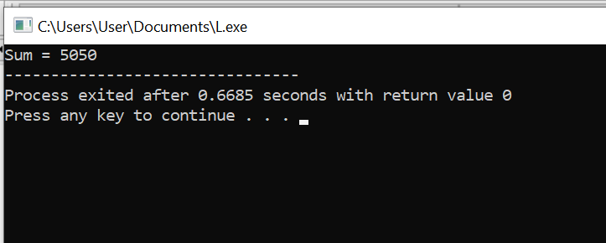

2. Print all even numbers between 1 and 50

Program
#include <iostream>
using namespace std;

int main () {
int i = 2;

while (i <= 50) {
cout << i << " ";
i += 2;
}
return 0;
}
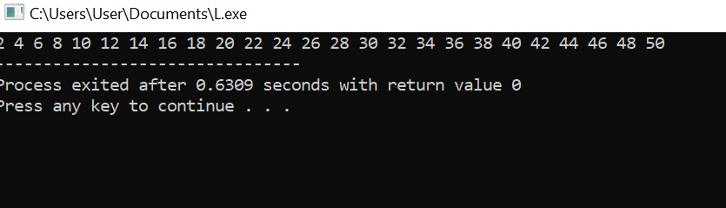

Output
2 4 6 8 10 12 14 16 18 20 22 24 26 28 30 32 34 36 38 40 42 44 46 48 50

3. Factorial of a number using while loop

Program
#include <iostream>
using namespace std;

int main () {
int num, fact = 1;

cout << "Enter a number: ";
cin >> num;

while (num > 0) {
fact = fact * num;
num--;
}

cout << "Factorial = " << fact;
return 0;
}
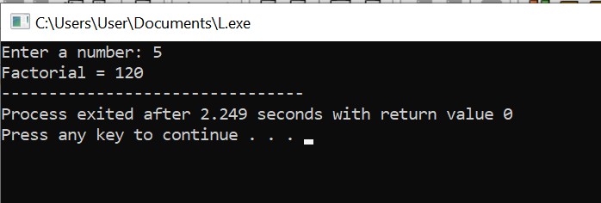

Sample Input
5

Output
Factorial = 120

4. Password check using while loop

Program
#include <iostream>
using namespace std;

int main () {
int password;

cout << "Enter password: ";
cin >> password;

while (password!= 1234) {
cout << "Wrong password! Try again: ";
cin >> password;
}

cout << "Access Granted!";
return 0;
}
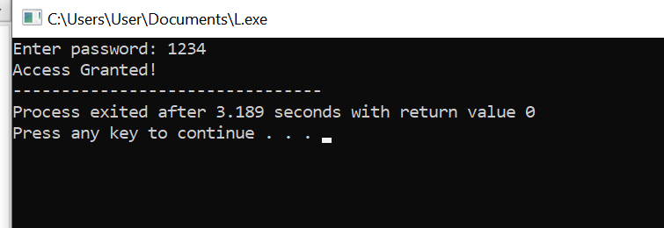

Sample Output
Enter password: 111
Wrong password! Try again: 222
Wrong password! Try again: 1234
Access Granted!

5. Reverse a number using while loop

Program
#include <iostream>
using namespace std;

int main () {
int num, reverse = 0;

cout << "Enter number: ";
cin >> num;

while (num > 0) {
reverse = reverse * 10 + (num % 10);
num = num / 10;
}

cout << "Reversed number = " << reverse;
return 0;
}
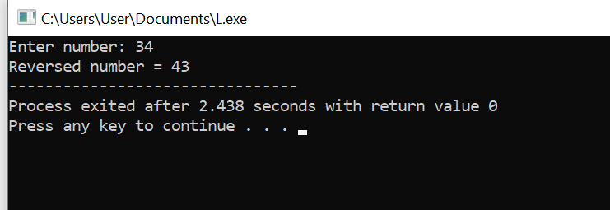

6. Multiplication table using while loop

Program
#include <iostream>
using namespace std;

int main() {
int num, i = 1;

cout << "Enter number: ";
cin >> num;

while (i <= 10) {
cout << num << " x " << i << " = " << num * i << end;
i++;
}
return 0;
}
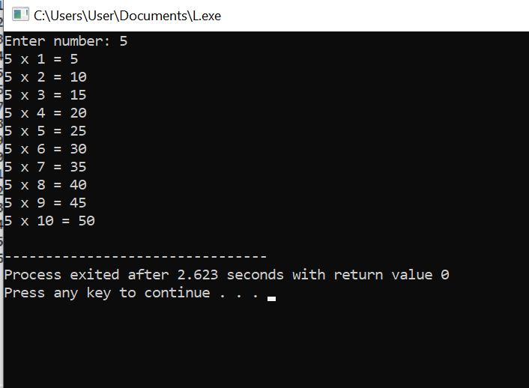

Sample Input
5

Output
5 x 1 = 5
5 x 2 = 10
5 x 3 = 15
5 x 4 = 20
5 x 5 = 25
5 x 6 = 30
5 x 7 = 35
5 x 8 = 40
5 x 9 = 45
5 x 10 = 50

7. Sum of digits of a number using while loop

Program
#include <iostream>
using namespace std;

int main() {
int num, sum = 0;

cout << "Enter a number: ";
cin >> num;

while (num > 0) {
sum = sum + (num % 10);
num = num / 10;
}

cout << "Sum of digits = " << sum;
return 0;
}
